**Kol Simcha Torah Gazette**

**For parsha bamidbar &**

**yom tov shavuos 5785**

Volume 9 Issue 35 (Whole #450) 26 Iyar 5785/ May 24, 2025

**Printed L’illuy nishmas Nechama bas R’ Noach, a”h**

For a free subscription, please forward your request to [***keren18@juno.com***](mailto:keren18@juno.com)

***Past emails can be found on the website ShabbosStories.com under Brooklyn Torah Gazette***

**Chief Rabbi David Yosef Hugged**

**The Recalcitrant Husband and**

**Persuaded Him to Grant a Get**

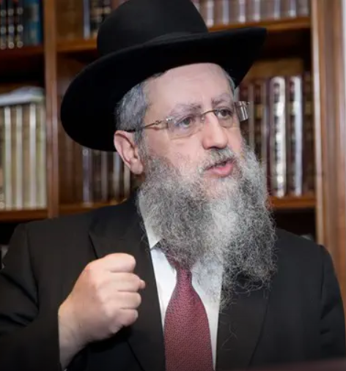

**JERUSALEM** — In a rare and extraordinary intervention by the Rishon LeZion and President of the Great Rabbinical Court, Rabbi David Yosef, he personally succeeded in securing a get for an Agunah trapped in a difficult and abusive marriage with a violent and stubborn husband.

The story began years ago, when a young secular couple, who later embraced a religious lifestyle inspired by Breslov, lived together before marriage. At some point, the man became entangled in legal issues in Israel and fled with his partner to Uman, Ukraine. Under pressure from the local Breslov community, they married according to Jewish law.

However, the marriage quickly deteriorated. The young woman became pregnant and was subjected to severe physical abuse. As she neared childbirth, the couple returned to Israel, where she gave birth to their son.

Following the birth, violent altercations resumed, and the woman was repeatedly beaten—once even found unconscious. With no other choice, she fled with her baby and filed a case with the regional rabbinical court. The court summoned the husband with the help of police and arrest warrants, but he went into hiding.

The case was transferred to the Division for Preventing Agunot, headed by Rabbi Eliyahu Maimon. With the help of a private investigator, the husband was eventually located in Meron, northern Israel. All attempts to persuade him to grant a get failed. He swore he would never divorce his wife. The investigator called in the police, and the man was arrested under a court order—resisting violently and even attacking officers during the arrest.

From a Jerusalem detention facility, he was brought before the court presided over by Rabbi Yitzchak Ushinsky. He remained defiant through three hearings, insisting he loved his wife and would never give her a get. In collaboration between the rabbinical court administration, the Israel Prison Service (IPS) led by Commissioner Kobi Yaakobi, and the office of Rabbi Yosef, the IPS rabbinate contacted Rabbi Yosef and informed him of the husband’s ongoing refusal and request to speak with him.

Moved by the case, Rabbi Yosef personally entered the courtroom in Jerusalem—an unusual occurrence for the chief rabbi. He stepped down from the judges’ bench, sat beside the prisoner, who was surrounded by six IPS officers, embraced him, and spoke to him at length from the heart.

At a certain moment, the man broke down in tears and agreed to give the get on the spot. A scribe and witnesses were immediately summoned, the get was written and delivered, and the young, abused woman was finally freed.

Rabbi Eli Ben-Dahan, Director of the Rabbinical Courts, praised Rabbi David Yosef for “bringing a new spirit and a direct, personal approach to resolving the difficult situations faced by litigants.” He also commended Rabbi Eliyahu Maimon and his team for their tireless efforts, day and night to free women trapped in marriages against their will.

*Reprinted from the May 22, 2025 website of VINnews*

**Rav Avigdor Miller on**

**How Can I Teach Myself**

**To Think Before I Speak?**

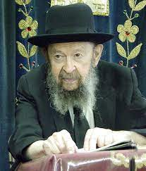

I told you this already; make up your mind that for the next two hours whenever somebody speaks to you're going to refuse to answer you unless you count first to five. Shlomo Hamelech says that; he says you shouldn't hurry to open your mouth.

Don’t be in a hurry to open your mouth, to say what’s on your mind (Koheles 5:1).

If somebody says something to you, the first thing is don't hasten to open your mouth. And so isn’t that a good idea, to count to five? It's good you came here tonight. And so for the next two hours when somebody says something to you, count to five. Do it also tomorrow for two hours. And the day after. And after a while you'll get into the habit of thinking before you talk.

By the way, when you talk to important people, you'll notice that even gentiles, l’havdil, have learned not to shoot their mouths off. The best thing is you don’t answer at all. A lot of small things you don't have to answer at all. You don’t have to answer all the time. But if you must, then take your time before you answer. Count; one, two, three, four, five, and then you answer. That itself makes you considered a wise man to other people.

January 1984

*Reprinted from a recent email of Toras Avigdor based on a Thursday night lecture delivered on January 1984.*

**Why the Exodus from Egypt is Greater Than G-d’s Creation of the World**

**From the Teachings of the Lubavitcher Rebbe**

**Rabbi Menachem Mendel Schneerson, Zt”l**

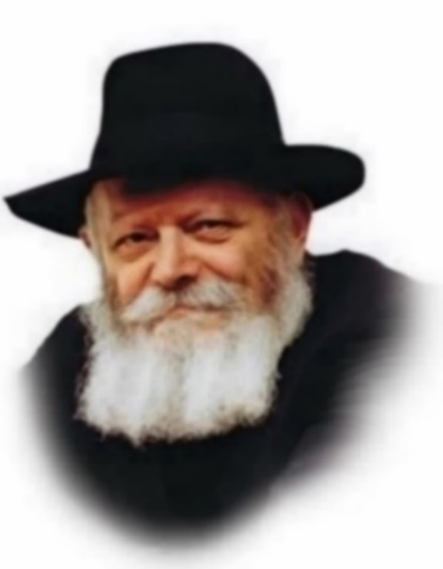

Shavuot is the holiday on which we celebrate the giving of the Torah, when G-d Himself descended on Mount Sinai before the entire Jewish people. The world stood still as G-d's voice thundered the first of the Ten Commandments: "I am the L-rd your G-d, Who took you out of the land of Egypt."

Our Sages asked a pointed question: What was so special about the exodus from Egypt that G-d chose to mention it in the very first Commandment? Why not "I am the L-rd your G-d, Who created heaven and earth"? Is not the creation of the world more fundamental than an isolated historical incident involving only a few million people?

In addition, the exodus from Egypt, although a great miracle, involved only that generation. The existence of the physical world, however, is a phenomenon which each generation can point to as evidence of G-d's greatness. Why then did G-d give the exodus such prominence at the moment of His revelation to mankind?

Chasidic philosophy explains that in certain respects, the Jewish people's liberation from bondage in Egypt was an even greater event than the creation of the world. G-d created the world ex nihilo - substance out of nothingness - something which we, as created beings, cannot comprehend. Although the creation of the world was a wondrous event, for an all-powerful, eternal and infinite G-d, it was no particular feat.

Furthermore, the Torah states that the world was created by G-d's speech. "By the word of G-d the heavens were created, and by His breath all of their hosts." Speech is an external power, produced without exertion. The world was created in such a way as to express only the outermost fraction of G-d's true might.

The exodus from Egypt, however, was a miracle of a totally different kind. In order for the Jews to leave Egypt, G-d had to supercede the laws of nature He had already created. G-d Himself, not an angel, led the Jews as they departed. Abrogating natural law to free the Children of Israel involved an even higher level of Divine intervention than creating the world in the first place! The exodus from Egypt was therefore given the top billing it deserved in the Ten Commandments.

Likewise, in our own lives, we sometimes find that it is harder to change ingrained habits than to begin a completely new undertaking. When G-d took our forefathers out of Egypt (Mitzrayim), He gave each and every Jew the strength to break through the boundaries and limitations (metzarim) which stand in his way. This innate power, bestowed upon the Jewish people when the Torah was revealed, gives us the ability to overcome any negative habits or character traits which prevent us from serving G-d with a full heart.

***Reprinted from the Behar-Bechukosai 5762/2002 edition of L’Chaim. Adapted from the works of the Lubavitcher Rebbe.***

*\*\*\*\*\*\*\*\*\*\*\*\*\*\*\*\*\*\*\*\*\*\*\*\*\*\*\*\*\*\*\*\*\*\*\*\*\*\*\*\*\*\*\*\*\*\*\*\*\*\*\*\*\*\*\*\*\*\*\*\*\*\*\*\*\*\**

**And Israel encamped there opposite the mountain (Ex. 19:2)**

Why was the Torah given on a mountain? The difference between level ground and a mountain is not qualitative; both are made of dust and earth. A mountain is just more of that earth collected and heaped up into a larger mass. The fact that the Torah was given on a mountain teaches us that a Jew's purpose in life is to take that earth-physical matter and corporeality- elevate it, and transform it into holiness. (The Lubavitcher Rebbe)

**Shavuot**

"Shavuot" comes from the word "shvua" - oath. On the day that the Torah was given, both G-d and the Jewish people made a mutual vow to each other. We swore to G-d that we will never exchange Him for another god and He swore to us that He will never exchange us for another nation. (Ohr HaChaim Hakadosh)

*Reprinted from the Shavuos 5762/2002 edition of L’Chaim, a publication of the Lubavitch Youth Organization.*

**Rabbi Berel Wein on ????? 5785**

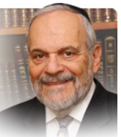

The count of the Jewish people as it appears in this week’s parsha is always a difficult issue to appreciate and understand. What are we to learn from all of the detailed descriptions and seemingly exact numbers? The general lesson that every Jew counts – and is to be counted, is most apparent. But that lesson can be learned from a much more concise précis of the population of the Jews than the long description that appears in the parsha.

I think that the messenger here is itself the message. By that I mean that the Torah wishes to express its relationship to the Jewish people simply by dwelling on an “unnecessary” lengthy detailed counting of its numbers. For those with whom we have a loving relationship, there are no unnecessary or superfluous acts or gestures. The rabbis compare this type of relationship, in a wry way, to one counting one’s money.

For instance, the criterion for the speed and intensity of reciting the words of prayer is the rate of speed that one would use in counting valuable coins. The care in counting is itself the expression of the underlying attachment to what is being counted. I always note that people leaving the ATM cash dispenser invariably check the bills that they have received. This is not only an act of prudence; it is an act of affection and importance.

So, the count of the Jews in the parsha, even in its detail and length, is logical and makes perfect sense. Another understanding of this issue can be found in the description of the counters themselves and not only in the description of the ones counted. Moshe, Aharon, Elazar and Itamar are the leaders of the Jewish people. They are responsible for the physical and spiritual welfare of the Jewish people in its totality. Part of their task is to somehow know all of their millions of constituents – to have some sort of relationship and affinity to each individual Jew.

The leaders of Israel always saw themselves as being parents of all Jews. Some Jews crave affection and others need very tough love. The enormous diversity – twelve different tribes that are counted separately before being united in one total number of the whole people – of the Jewish people, is emphasized by the sheer individual counting of them.

The responsibility for the fate of the Jewish people is a heavy burden for leaders to bear. But it is an unavoidable one that automatically comes with the posts of leadership. And the counters of the Jewish people are themselves the leaders of the people, aware at all times that the people rely upon their leadership and wisdom. And they must also be aware that each of those counted are somehow to be accommodated in their needs and development.

So, counting the Jewish people are not empty numbers to the leaders of Israel but rather, the list of challenges and opportunities presented before them. May both the counters and the counted of Israel in our day be great in numbers, spirit and accomplishments.

Shabat shalom.

*Reprinted from the current website of rabbiwein.com*

*\*\*\*\*\*\*\*\*\*\*\*\*\*\*\*\*\*\*\*\*\*\*\*\*\*\*\*\*\*\*\*\*\*\*\*\*\*\*\*\*\*\*\*\*\*\*\*\*\*\*\*\*\*\*\*\*\*\*\*\*\*\*\*\*\*\**

***You shall take a count of the Congregation of Israel* (Num. 1:2)**

When a count is taken, no distinctions are made between what is being counted. The great and the small are both equal, each having the value of one. The Torah portion of Bamidbar is always read on the Shabbat before Shavuot, the holiday on which the Torah was actually given on Mount Sinai, for all Jews stand equal on that day. Our Sages said that if even one Jew had been missing, the Torah would never have been given! (The Lubavitcher Rebbe)

**"I am the L-rd your G-d."**

Why did G-d use the singular form when giving the Ten Commandments to millions of people? To teach us that each and every Jew must say to himself, "The Ten Commandments were given to me, and I must keep them." One should not think it is sufficient that the Torah is kept by others. (Midrashim)

*Reprinted from the Behar-Bechukosai 5762/2002 edition of L’Chaim.*

**When I Decided to Take G-d and Religion Seriously**

**By** [**Rabbi Nechemia Coopersmith**](https://aish.com/authors/rabbi-nechemia-coopersmith)



*I ignored God more out of ignorance and apathy than informed choice.*

As a teen I fell into the category of what is today called the "Nones", someone who doesn’t identify with any religion.

According to [the Pew Research Center](https://www.pewresearch.org/religion/2021/12/14/about-three-in-ten-u-s-adults-are-now-religiously-unaffiliated/), the Nones are the fastest growing segment of the American population. In 2021, about three-in-ten U.S. adults (29%) describe themselves as atheists, agnostics or “nothing in particular” when asked about their religious identity – 6% higher than five years ago. According to a 2020 Pew Report, 27% of American adult Jews say they do not identify with Judaism.

I went to Hebrew school and synagogue on the High Holidays decked out in a snazzy suit. We had a large family Passover Seder with gefilte fish, matzah, the four questions, hunting for the afikomen, as many of the guests gravitated to the den for the real action – watching the Stanley Cup playoffs game.

Judaism was a quaint set of traditions, not a religion that I took seriously. That’s probably why my friends and I never heard of Shavuot, the Jewish holiday that commemorates the giving of the Torah to the Jewish people at Mount Sinai, 50 days after the exodus from Egypt. What meaning could Shavuot have to someone like me who had no clue if there was a G-d and viewed the rules of Judaism as antiquated and irrelevant? It wasn’t on my radar, not even as an excuse to miss school.

I ignored Shavuot the same way I ignored the issues related to G-d – more out of ignorance and apathy than informed choice.

**A Burning Desire for Meaning**

That changed when I recognized my burning desire for meaning and decided to take the question of G-d’s existence seriously. Is there evidence that G-d exists (I wasn’t prepared to take a leap of faith)? What is the definition of G-d and what difference would He make in my life?

I discovered that the basis for Judaism is a search for truth, built on a preponderance of evidence and rational argument. The first of the Ten Commandments is “to know” that G-d exists – not to just blindly accept. After six months of delving into the various arguments and classical Jewish texts, I was at a crossroads. Where does the evidence lie? Weighing the question of the existence of G-d and the Divine authorship of the Torah, in what direction did the scales tip?

Even tentatively moving from the category of “The Nones” to "A Believer” made me queasy.

For me, merely asking this question was a radical departure. It was the first time I was taking G-d seriously and I was torn. I wasn’t eager about adopting certain religious practices. Even tentatively moving from the category of “The Nones” to “a Believer” made me queasy. Most of the religious people I was exposed to growing up were Bible-thumping TV evangelists who didn’t quite impress me with their intellectual rigor. Was I becoming one of them?

**Signing on the Dotted Line**

**Before Reading the Fine Print**

When the Jews stood at Mount Sinai and G-d offered them the Torah, they replied as a unified nation, “*Naaseh v’nishma* – we will do and we will understand.” They accepted the Torah and all of its commandments right off the bat, without knowing everything that it entails. They signed on the dotted line, and only afterward read the fine print.

Contrast this with how the non-Jewish nations responded to G-d's offering them the Torah. The Talmud says each nation asked, “What’s written in it?” which is a reasonable question. We want to know what we’re getting ourselves into if we sign this contract. G-d answered each nation by telling them the very commandment they were loath to accept, and each one rejected it.

What’s going on here? The impulsive Jews accept the Torah, no questions asked, and the reasonable-minded non-Jewish nations end up refusing it. Why?

G-d doesn’t need your stamp of approval. As the Creator of the universe and the source for all of existence, He determines reality. On offer wasn’t just a new self-help book full of advice and guidance from which you can pick and choose; [the Torah is the blueprint of creation](https://aish.com/why-would-anyone-want-to-be-commanded/), the transcendent map that reveals the structure, purpose, and inter-connectedness of the entire universe. Its commandments enable one to harmoniously connect to its Author, becoming  attached to the Infinite.

Once they knew the Torah was coming from G-d, they were ready to commit because that was Truth, regardless of how they felt about it.

The Jews standing at Sinai heard G-d speak. Once they knew the Torah was coming from G-d – and yes, that’s a huge condition – they were ready to commit because that was Truth, regardless of how they felt about it.

The other nations who asked, “What’s written in it?” were essentially telling G-d, “Let me see if this Torah fits into my lifestyle and if I like it.” The very question was a rejection; they were more interested in staying in their comfortable bubble than going with the truth.

**My Personal Sinai**

I wasn’t [standing at Mount Sinai](https://aish.com/tuning-in-to-the-sinai-frequency/) hearing G-d speak, so I didn’t have the clarity they had. But the offer on the table was similar, albeit messier and laced with some doubt: [Examine the evidence](https://aish.com/did_god_speak_at_sinai/) for the Divine authorship of the Torah and if you think it’s compelling (again, a big if), do you want in? Are you prepared to say as the Jews at Sinai replied, “*Naaseh v’nishma* – we will do and we will understand”?

The holiday of Shavuot replicates the acceptance of Torah. It reminds me to set my sights on truth, not comfort. When it boils down to listening to G-d or my inner desires, I need to humble myself and subjugate my values to His values. It’s not easy, but if Torah is real, then I need to do the changing, not G-d. That’s the “we will do” part. Then there’s the “we will understand” – which means I have the unmatched opportunity to devote my lifetime to studying G-d’s blueprint and strive to understand as much as I possibly can, infusing my life with meaning and connecting to [His boundless love](https://aish.com/the-ultimate-love-letter/).

That’s what it means to take G-d and Torah seriously.

***Reprinted from the current website of aish.com***

**Charlie ‘Buttons’ Nassofer, 80, Brought Joy to the Rebbe, and Generations of Children and Adults**

**By** [**Motti Wilhelm**](https://www.chabad.org/search/keyword_cdo/kid/23487/jewish/Wilhelm-Motti.htm)

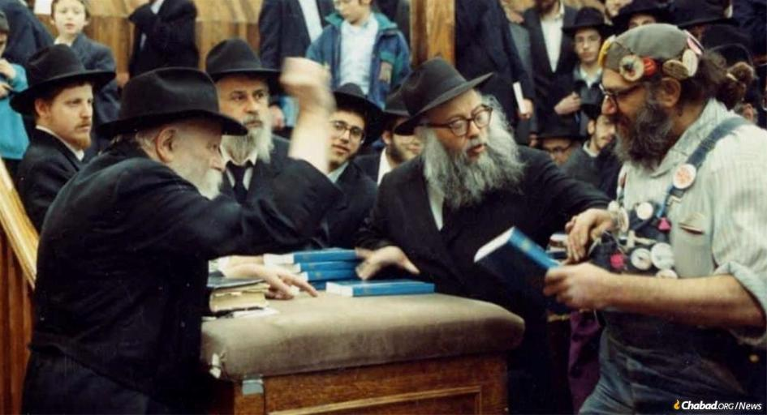

**The Lubavitcher Rebbe showed Charlie special warmth and attention. Almost every time Charlie passed by the Rebbe, he was greeted with a broad smile and an encouraging wave of the hand.**

For decades, at nearly every engagement party in the Crown Heights neighborhood of Brooklyn, N.Y., children would gather near the door, waiting with anticipation. At some point during the celebration, the door would swing open, and the children would shout with glee, “He’s here! He’s here!”

The man who inspired such excitement was Charlie Nassofer—better known as “Charlie Buttons” due to the dozens of colorful pins bearing Jewish messages adorning his cap and overalls. Where he lived remained a mystery to most, with few even knowing his real last name. But one thing was certain: He could always be counted on to show up carrying a stack of uninflated balloons. Charlie would blow up and shape the balloons, handing them out to the children. His signature gesture at engagement parties was crafting a red balloon heart for the bride and groom.

A colorful figure who brought joy wherever he went, he became a fixture at countless *simchas*. He was also famously present at every [*shalom zachar*](https://www.chabad.org/library/article_cdo/aid/377526/jewish/What-is-a-Shalom-Zachar.htm)—the traditional Friday-night celebration after a baby boy is born. With thousands of Jewish families in Crown Heights, there were often several such gatherings each week, yet Charlie would make his rounds, trudging along in his untied work boots.

At the time of his passing on Thursday, May 8—the eve of 11 Iyar—Charlie had been in poor health for well over a decade, spending most of his time in a nearby Brooklyn Jewish nursing home. Yet his passing was still met with a sense of visceral sadness. Charlie was a fixture—an icon, really—and his death felt like the end of an era.

Social media quickly filled with photos of Charlie at engagement parties, bar mitzvahs and other community events. Even more poignant were his dozens of memorable moments with [the Rebbe](http://therebbe.org/)—Rabbi Menachem M. Schneerson, of righteous memory—to whom he often brought a smile.

For someone so unconventional, Charlie left behind a surprisingly large paper trail, documenting many facets of his life and escapades.[1](javascript:doFootnote('1a6895826');) But most of these details only surfaced in the days following his passing. Because for so many in Crown Heights and around the world, their affection for Charlie wasn’t rooted in his past. They loved him simply because he was the irreplaceable Charlie Buttons.

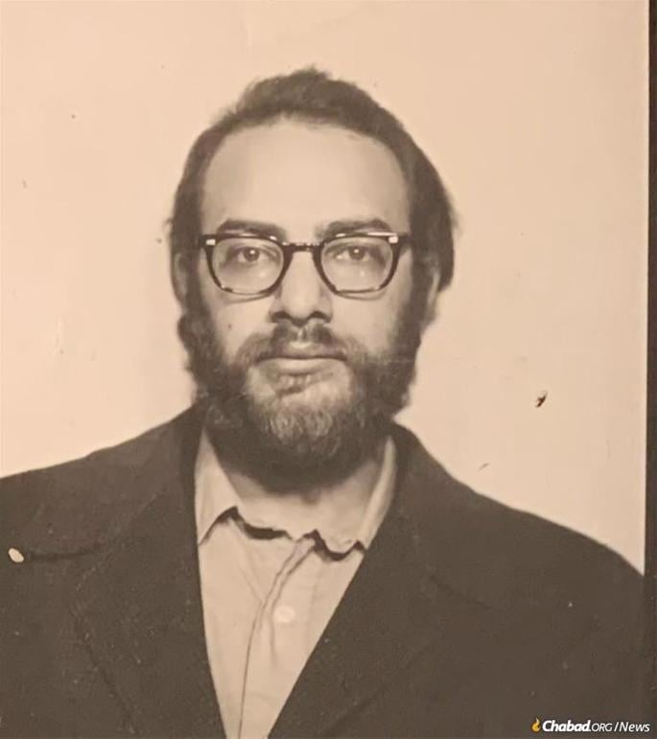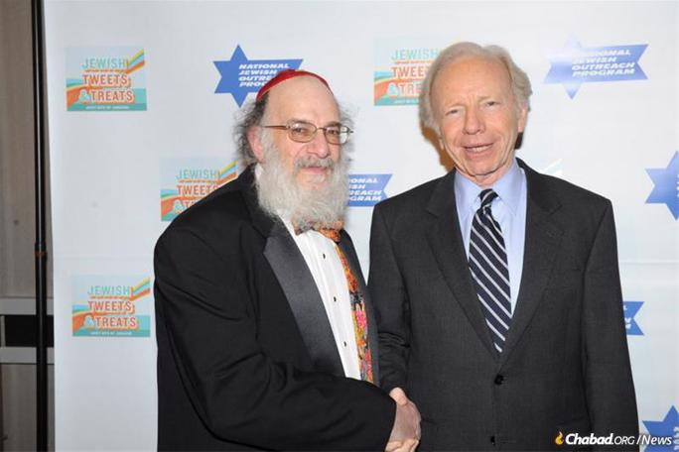

**Young Charlie and with Sen. Joe Lieberman of Connecticut**

Charles Nassofer was born on July 9, 1944, to Irving and Marcia Nassofer in Kearney, Neb., where his father was stationed at the U.S. Air Force Base, working as an airplane repairman.[2](javascript:doFootnote('2a6895826');) Eight days later, his *brit milah*—the ritual circumcision—was officiated by a rabbi from Omaha. A small headline in the local newspaper the following day reported: “Rabbi Katz Officiates at Christening [sic] Ceremony.”[3](javascript:doFootnote('3a6895826');)

The sages of Kabbalah teach that when parents give their child a Jewish name, it’s not just coincidence or personal preference—G‑d inspires them to choose the name that aligns with the child’s soul.[4](javascript:doFootnote('4a6895826');) Charlie’s parents gave him the name “Tzadik”—a familiar word but a rare name. In hindsight, it seems like a Divinely-inspired glimpse into the future.

Sometime over the following years, the family moved to Brooklyn, settling in the East Flatbush neighborhood. The 1950 U.S. Federal Census lists them as living on E. 48th St. Charlie attended the local public school and Hebrew school at nearby Congregation Beth Judah. According to Charlie’s recollection in several interviews, his father once brought him to see the Rebbe at 770 when he was a young child.

In 1954, Irving Nassofer passed away at the age of 40, leaving behind his wife, son and two daughters. Charlie’s mother, who worked as a bookkeeper at Beth Judah, continued in her position while raising the family. For high school, Charlie attended Brooklyn Technical High School, then began college studies but eventually dropped out. His sister Elaine remembers him as “very good-looking and very smart.”

In 1964, while on a visit to Florida, Charlie and his sister Lottie were involved in a serious car accident, in which Charlie sustained brain damage.[5](javascript:doFootnote('5a6895826');)

In the years that followed, the series of events that shaped him into the much-beloved “Charlie Buttons” began to unfold. By the mid-1970s, Charlie was attending Jewish singles events in Manhattan. At one such event, a woman from the Chabad-Lubavitch community [arrived with Shabbat candle-holders](https://www.chabad.org/therebbe/article_cdo/aid/3702113/jewish/The-Shabbos-Candle-Lighting-Campaign.htm) to encourage the young women to light Shabbat candles. Charlie thought it was a great idea to hand them out regularly at these events, and he asked her where he could get more. She directed him to Crown Heights.

Charlie took the subway and ended up meeting Rabbi Kasriel Kastel, program director at the [Lubavitch Youth Organization](https://www.chabad.org/jewish-centers/117669/Brooklyn/Synagogue/Lubavitch-Youth-Organization-Headquarters). Rabbi Kastel offered him the opportunity to don *tefillin*and invited him to attend programs the organization was running. “And that’s how I ended up in Crown Heights,” Charlie recalled decades later.

**The Court Jester**

In his overalls and large, distinctive yarmulke, Charlie quickly became an icon in Crown Heights, especially in the synagogue at [770 Eastern Parkway](https://www.chabad.org/library/article_cdo/aid/6277677/jewish/What-Is-770-Eastern-Parkway.htm), Lubavitch World Headquarters. He became deeply enamored with the Rebbe, who in turn showed him special warmth and affection. Almost every time Charlie passed by the Rebbe, he was greeted with a broad smile and an encouraging wave of the hand.

Charlie’s unique relationship with the Rebbe played out both in public and in private. When receiving *kos shel brachah*—the traditional wine of blessing from *havdallah*marking the end of Shabbat or a holiday—Charlie would approach the Rebbe holding three cups instead of the one cup everyone else had. He later explained that the cups represented *chochmah*, *binah* and *daat*—the acronym of Chabad. The Rebbe would patiently pour wine into each of Charlie’s cups, and then swing his hand in encouragement, which would usually send Charlie into a euphoria. He’d dance his way down from the platform where the Rebbe was standing.

There were also private moments. Charlie would sometimes stop the Rebbe on the street for a conversation, though he never revealed what they discussed. On one occasion, after losing his signature [yarmulke](https://www.chabad.org/library/article_cdo/aid/3913641/jewish/The-Kippah-Yarmulke.htm) while swimming in the ocean, he wrote to the Rebbe to share what had happened. According to Charlie, the Rebbe responded by sending him a new one.

That yarmulke played a key role in transforming him into the beloved “Charlie Buttons.” Charlie had a hobby of collecting buttons, which he proudly pinned to his large yarmulke. Many featured logos of Jewish organizations or carried messages encouraging mitzvot like Shabbos or [*tefillin*](https://www.chabad.org/library/article_cdo/aid/1918251/jewish/What-Are-Tefillin.htm). Others were rank badges from [Tzivos Hashem](https://www.chabad.org/kids/article_cdo/aid/354741/jewish/Tzivos-Hashem-Club.htm" \o "Tzivos Hashem Club), [Chabad](https://www.chabad.org/library/article_cdo/aid/244369/jewish/About-Chabad-Lubavitch.htm)’s children’s organization. It’s no surprise, then, that he earned the nickname Charlie “Buttons”—so much so that most people knew him only by that name.

At some point, Charlie began attending weddings, engagement parties and other celebrations throughout the community, becoming a beloved and unmistakable presence at nearly every simcha in Crown Heights.

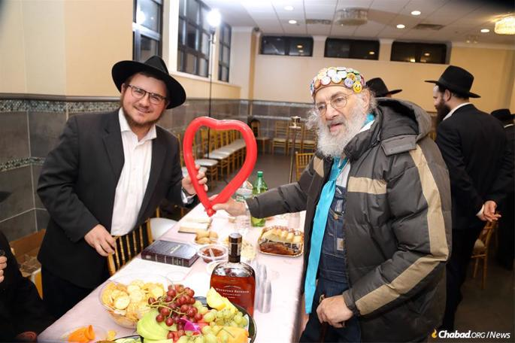

**For decades, Charlie "Buttons" Nassofer brought joy (and balloons) to countless celebrations in Crown Heights. *Courtesy of the Feller family***

“At first, I only went to weddings,” he once told an interviewer. “It’s the mitzvah of bringing joy to the bride and groom. Then I thought—why not go to the engagement parties too? That’s also a chance to make them happy. From there, it grew to include *brises, shalom zachars, melaveh malkahs*—everything.”

And wherever Charlie went, his balloons came with. He’d blow them up and twist into animals and creative shapes that delighted children and, yes, even the adults.

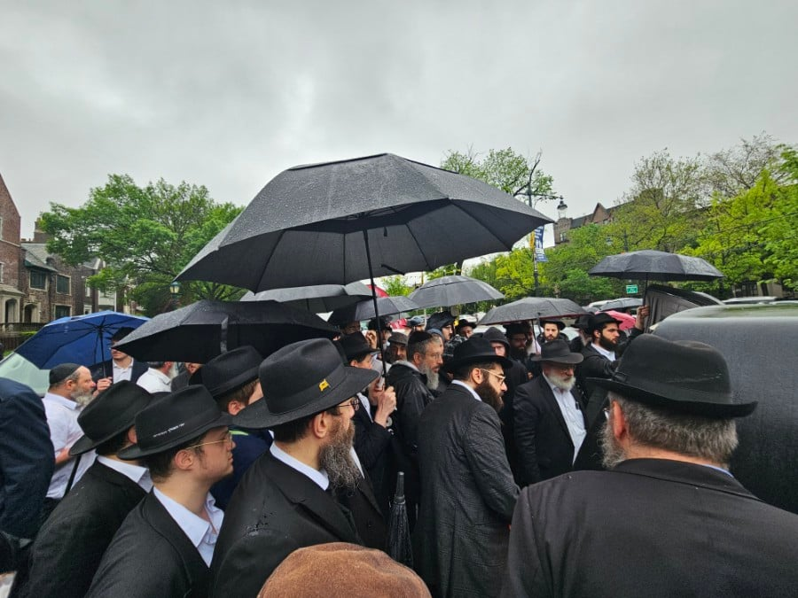

**Some of the many mourners at the Levaya for Charlie “Buttons” Nassofer**

At one point Charlie worked at the United States Postal Service, but that job quickly ran into complications. According to Rabbi Ephraim Buchwald, Charlie—who was “exceptionally brilliant” and showed signs of being a savant—figured out how to work with remarkable efficiency, which didn’t sit well with the union.

“Reputedly, he lost his job because he figured out how to service one of the large sorting machines in just two hours instead of the usual 18,” said Rabbi Buchwald. “The union accused him of causing other postal workers to lose work.”

Another point of contention was Charlie’s observance of Shabbat, which the USPS was unwilling to accommodate. Over the years, he was hired and fired by the Postal Service four times and spent decades trying to be reinstated.

As an alternative occupation, Rabbi Buchwald taught Charlie how to kosher kitchens. Charlie would carry out this work for anyone who requested Rabbi Buchwald’s help, including in some of Manhattan’s most luxurious homes.

“Charlie would show up in his overalls, with his koshering pot and his oversized oven mitts,” Rabbi Buchwald recalls. “He went that way to the homes of those who couldn’t afford to pay, and even billionaires. And no matter who they were, they all grew fond of him.”

“Charlie was the epitome of the [Talmud’s description](https://www.chabad.org/torah-texts/5443242/The-Talmud/Shabbat/Chapter-9/88b) of those ‘Who are insulted and do not insult, who hear their shame and do not respond, who act out of love and are joyful in suffering,’”[6](javascript:doFootnote('6a6895826');) says Nechama Dina Cohen of Beitar, Israel, who spent many a Shabbat meal with him at the home of her grandparents, Rabbi Eliezer and Raizel Zirkind. “Regardless of what anyone would say to him, he always stayed positive, was always happy and smiling, and only saw the positive in everything and everyone.”

“People whispered Charlie was a hidden *[tzadik](https://www.chabad.org/library/article_cdo/aid/2367724/jewish/Tzaddik.htm" \o "What Is a Tzaddik?)—*one of the 36 righteous people upon whom the world stands,” writes Rabbi Mordechai Lighstone, Chabad.org’s social-media editor. “I'm not an expert in hidden *tzadikim* ... but in a way, the joy he brought to others, he was already revealed.”

*Excerpted from the current website of Chabad.Org*